**Lab 04**

**Objectives:**

This lab will enable students to:

* + Code using Behavioral level modeling
  + Implement an 8 Bit Ring Counter

**TASK:**

**Implementation of a 8 bit Ring Counter**

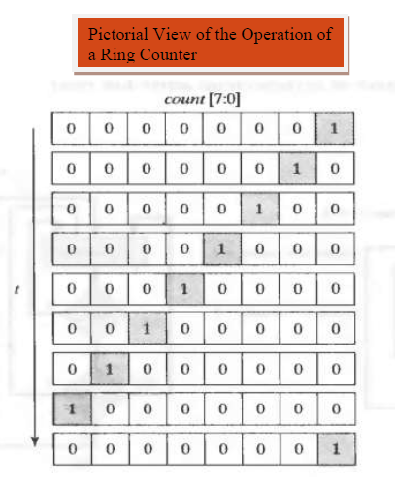**Block Diagram:**

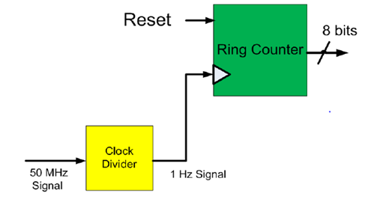

**I/O Connections:**

The output of the Ring Counter should be connected to 8 LEDs. The clock input is connected to pin “T9” on the S3 board. The LEDs should turn on and off one by one from left to Right with an interval of 1 second.

Note: Write a test bench as well in modelsim to test the functionality of the counter.